|  |  |  |  |  |
| --- | --- | --- | --- | --- |
|  | |  | | |
| https://fbcdn-sphotos-c-a.akamaihd.net/hphotos-ak-ash3/216615_240708389294346_6446658_n.jpg |  | | KapcsolÃ³dÃ³ kÃ©p |

**Supporting organisation Jobbadni Nonprofit Kft**  
1146 Budapest, Hungária krt. 200.   
Legal representative: Mr. Márton Juhász  
E [ode@reformatus.hu](mailto:ode@reformatus.hu)  
T +36(1) 4600706  
W [odeprogramiroda.hu](http://www.odeprogramiroda.hu)  
Insta: odevolunteers

**Duration of your service: 1. September 2023 - 31. July 2024, 11 months.**

**Language course and welcome seminar:**Volunteers will be invited to 3 ÖDE seminars and to trainings organised by the National Agency. Each volunteer will have a supervisor for task related support and also a mentor for helping volunteers in their personal development and integration.

We also offer Hungarian language lessons for the first 6 months.

**We are looking for volunteers at the following hosting placements:**

1. MRSZ Office in Ózd – working with Roma kids (2 free)
2. Bethesda Children Hospital in Budapest (1 free, 2 taken)
3. University Congregation in Debrecen (2 free)
4. Sarepta Home for Disabled in Budapest (3 free, 1 taken)
5. Homeless Shelter in Budapest (2 free)
6. Kalunba Charity – Refugees in Budapest (3 free)
7. Foundation of Garai Ház for Disabled in Baja (2 free)
8. Magyar Kékkereszt Association – Alcohol rehab centre in Dömös (2 free)
9. The Immanuel Home and School for Disabled children in Debrecen (2 free)

**Total: 22 volunteers**

# Placements and tasks

## MRSZ Office - ÓZD

|  |  |
| --- | --- |
| Jobbadni.hu | Magyar Református Szeretetszolgálat |  |

<https://jobbadni.hu/hirek/digitalis-tanevnyitot-tartott-a-magyar-reformatus-szeretetszolgalat-ozdon/>

The Ózd Office is doing its everyday work for the people in Ózd and supports them is different ways such as: The office is open from Monday till Friday where we welcome people, weekly we have ca 200 clients. We help locals with consultations, with

financial support, with second-hand clothing, with different programs for youth and

children.

We also advise clients with unemployment assistance and social services; we have a mentor-program for families in need:

- counselling local people

- give donations in many different forms (financial and in-kind support, to help clients to access social services)

- to help unemployed and people with housing difficulties,

- crisis management

- collecting and distributing donations

- Cooperation with other civil organizations and churches programs for children and young people.

The main task for volunteers:

1) Donation and personal related tasks: support families and children with donations, visiting families.

2) Tutoring and organizing afternoon activities for local children: helping with homework, paying time with them, outdoor activities.

3) Meseköz afternoon: this activity is once a month with handcraft activities, book reading, many interactive activities for small children.

4) Meseköz summer camp: we are planning for the summertime a one-week camp for disadvantaged children, with lots of activities, handcrafts, music, trips.

There are lots of families in difficult circumstances, with a lack of education, the family has a low income, they are facing marginalization. This project is about showing solidarity with children and young people living in poverty and to empower children and families with tools and hope in the future.

## Bethesda Children Hospital - Budapest



There are about 310 staff in the Hospital, where are around 150 nurses, 50 doctors and other staff for running the hospital everyday life.

The volunteers will meet also families and children while they are in the hospital and they will have the chance to talk about life generally in Hungary. The hospital is taking children not only from Budapest but also from the country-site.

The clients need in a difficult situation, lots of patience and committed staff, therefore it is also important that the volunteer first listen to the mentor and learn how the work environment is. We offer to volunteers a safe working environment where they can use their own creativity and inspiration to develop new ideas and little projects like taking also children out to walk and teach them new songs and games from other countries.

The volunteer is expected to be in the project 5 days a week, from Monday-Friday.The volunteer is expected to work from 8.00-15.00.

The voluntary activity will take 35 hours per week. Regular activity at the playroom at the rehabilitation department and neurology department: the games activities are diversified in accordance to the age of the children and the goal is to promote and to encourage the children so that they can forget their illness a little. The playroom is well supplied with toys and group games and there are different kinds of activities such as books, toys, drama, lessons etc.

Welcome room: this area offers the parents the opportunity to get to know to each other and to socialize. It is also welcomed when the volunteers are teaching new games or for example songs for the children.

The volunteer will try to use creative skills to make the parents and children happier. If the volunteer is interested s/he can keep the visitor’s company.

The volunteers will not work during National Holidays and they will get 2 days off each month.

The volunteers will help to go outside into the garden and play there. We also organise also time to time some visits in the city (i.e. circus).

The volunteers will get a nametag with their names so that everybody can see that they are volunteers and not nurses.

There will be another mentor outside of the hospital who will help the volunteer to reflect on her/his experiences like:

• In the beginning of the service agrees of regular meetings, talks for reflection

• Introduce and explain the framework of 8 key competences and Youthpass (the final Youthpass will be done with the help of the coordinating organisation)

• Ask the volunteer to keep a regular diary on his learning achievements (maybe to help to set up a blog as well)

• helps the volunteer to get know the city and its cultural sites.

The volunteers can learn

• A quality relationship through friendship, and positive social interaction

• Access to opportunities and positive experiences

• The chance to learn new life-skills and to gain new perspectives on life

• The opportunity to explore how the health system is working in Hungary

• Develop continuously skills like communication, problem solving and active listening.

The volunteers will meet also families and children while they are in the hospital and they will have the chance to talk about life generally in Hungary. The hospital is taking children not only from Budapest but also from the country-site. The social and economic environment is changing in the last few years due to the global economic crises; the unemployment rate is growing and the situation is sometimes difficult for families. The clients need in a difficult situation like the illness of the child, lots of patience and committed staff, therefore it is also important that the volunteer first listen to the mentor and learn how the work environment is. The volunteer will be supported to learn about these issues and how to support child and families.

## University Congregation - Debrecen

The University Congregation in Debrecen works with and serves university students.

Our church is part of the youth mission program of the Reformed Diocese called Tiszántúli Református Egyházkerület specifically aimed to serve students at the local university, the University of Debrecen. After the years of communism with reclaiming the church building from the state, the congregation restarted its work on the main campus in 2007 and had been actively presenting there ever since. Throughout the years the congregation partnered up with fellow congregations from the Reformed Church of America and with their help, it grew into a multisite church, which means it is present in all the three campuses of the University of Debrecen. One congregation holds services in three separate places.

The church members are university students and they serve also in groups to organize events. The purpose of the church is to create opportunities for religious students to practice their faith during their study years away from home and for non-religious students to get to know Christianity.

In the center of the church life, there are contemporary worships with youth music and preachings on topics close to the everyday life of university students. Besides this, religious and non-religious programs are organized in the church, like Bible study groups, worship events, board game nights, quiz nights, bbq parties, semester opening camp. The pastors give university lectures related to religion.

The programs are always changing fitting to the university life and needs of the students.

The recent programs are: Chill nights, Zacc hétfő, Kilépő, Bible study.

Chill nights aims to transfer the Bible message in new ways, like readings, music or theatrical play. On these events university students play music or act in a play that was written by them too.

Zacc hétfő (coffee grounds Monday): a coffee house style two hours on Monday morning when we serve coffee and some delicious surprises for students attending our events and they are free to invite their friends too. Between two lectures they stop by, have some chat and get ready to go for the next lecture.

Kilépő is a closed group in which students in their last university year can talk about their challenges concerning starting their adult life. It's a place to share their experiences and get support from each other.

Bible study is a regular church program when we talk about a chosen Bible text. Its freshness is based on the topics that emerge in these talks concerning everyday questions of student life.

We have been accreditated as EVS/Erasmus+ hosting organization during the last 7 years. Now we are applying for the Quality Label as a hosting organisation.

The University Congregation works with 4 staff at the University Church, at 3 different locations. The main building is the church at Egyetem ter 2, but we are also active at Böszörményi Campus and Kassai Campus. The volunteer activity will take place at Egyetem tér 2, and occasionally at the two other campuses.

## Sarepta Home (Sztehlo Gábor Ev. Szeretetszolgálat) for Disabled - Budapest

<https://www.facebook.com/Sarepta-Budai-Evang%C3%A9likus-Szeretetotthon-224928344642592/>

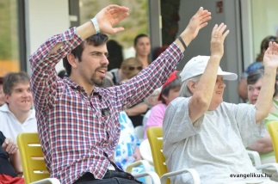

Sarepta home is for mentally disabled youths and adults, but for elderly people as well. At the area of the home are several buildings for living and also for different therapy activities. There are units for disabled and elderly as well.

The home offers 100 places for disabled people. Regarding the decision of the volunteer she/he can work with old people or people with disabilities. The home also offers home, special education, rehabilitation, workshops and physical therapy for people for disabilities. The institution offers physical, ergo and logo therapy and conductive therapy is also available.

The aim of the home is to give disabled people assistance; what they need for maintenance and achievement for the best possible independence. The home also offers different workshops for disabled like weaving, making small carpets also for selling outside the home and other creative workshops.

**Tasks for the volunteer**

Working hours: approx. min. 35 hours/week

60% creative and leisure time activities: organized leisure time activities and own initiatives, ideas for program activities.  
40% daily tasks: additional support, helping with meals (preparation), accompanying residents;

The volunteer is expected to be in the project 5 days a week, from Monday-Friday. The volunteer is expected to work from 8.00-15.00, with a 30 min. lunch break. The voluntary activity will take at least 35 hours per week but the volunteer will receive Hungarian language lessons every week which is also part of the working hours and not extra time.

## Tiszta Forrás Homeless Shelter - Budapest

<http://tisztaforrasa.5mp.eu/web.php?a=tisztaforrasa>

The foundation supplies four assignments:

1. Daily drop-in centre   
We provide food, sandwiches, tea, and ability to wash and to have a bath. We can provide our daily service up to 120-130 people daily this number can be extended 160 during crisis situation. We provide daily food for 450 clients.

2. Night shelters

Usually, we can provide housing for 35 men, high quality. In winter, in a crisis situation, the number of beds can be increased by 6. Most of the clients in the night shelter stay longer than one night. We provide cleaning facilities, well-equipped rooms are provided, lockable cupboards. The aim of the shelter is to socially reintegrate people without homes. We organize many programs to achieve this goal: excursions, theatre, cinema, garden outings, and celebration of national and religious vocations.   
3. Club for Anonym Alcoholics

We organize talks in groups one afternoon each week for the rehabilitated members and for  
enquirers. Enquirers who are not housed in the night shelter may also come, so the club welcomes everyone. There is also worship every Wednesday for people who need healing from their addiction.

4. Street social work

The part of this work is the social work on the streets, which quests and attends the homeless people in the 18th district. The aim of street social work is to help those people, groups and individuals who are staying on the street and who are distrustful with institutional care, with the primary aim to save their life and integrate them into the society. Street social service works in the framework of the daily drop-in centre.

**Tasks for the volunteer**

- Welcome newcomers and offer them tea and bread.

- Organize the clothes and help people find which ones they need.

- Hand out hygiene items (homeless people can use the shower and use the washing machine)

- Prevent security issues by listening to and speaking to people who are getting upset

- Help people find supplies they can use

- Assist with some street social work (Thursday and Friday): to help clients to deal with their medical, food or other needs.

- Helping staff with some administration.

Volunteers will work in two shifts. Morning-shift is from 7.00-14.00, afternoon-shift is from 11.30-18.00

## Kalunba Charity – Community Centre – Budapest

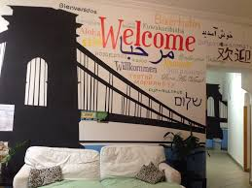

**Kalunba Social Services Association was founded in 2014 and actively serves refugees in Budapest. They are providing services such as housing assistance, employment, schooling programs, language lessons, as well as community building opportunities**.

Kalunba Social Services Ltd. (http://kalunba.org/), in cooperation with the Reformed Church in Hungary, aims to facilitate the integration of refugees into Hungarian society through integration support provided by professionals and volunteers. Kalunba runs a community centre for refugees and TCNs in the heart of Budapest, providing a variety of services and a meeting place for the community. It uses a holistic approach to create an opportunity for successful, full integration: support is provided in different fields such as housing, language classes, addressing learning difficulties, tutoring, finding employment, ensuring sustained employability and creating a friendly and supportive community. Overall, about 240 refugees and migrants are currently involved in the various activities of the centre.

1) Organisational activities: The volunteer will assist with the setting up and supporting groups of young people, children and families.

2) To teach English and Hungarian

3) The volunteers can also help in music programmes, there is a migrant choir

4) Team Working: volunteers will have the opportunity to network with

5) personal planning time for daily activities

6) Helping to organise different events for clients, talk to them, listen to them.

The volunteers will work 35 hours and mainly from early afternoon to the evening.

## Garai Ház Foundation - Baja

<https://www.facebook.com/438198492878684/posts/2120545957977254/>

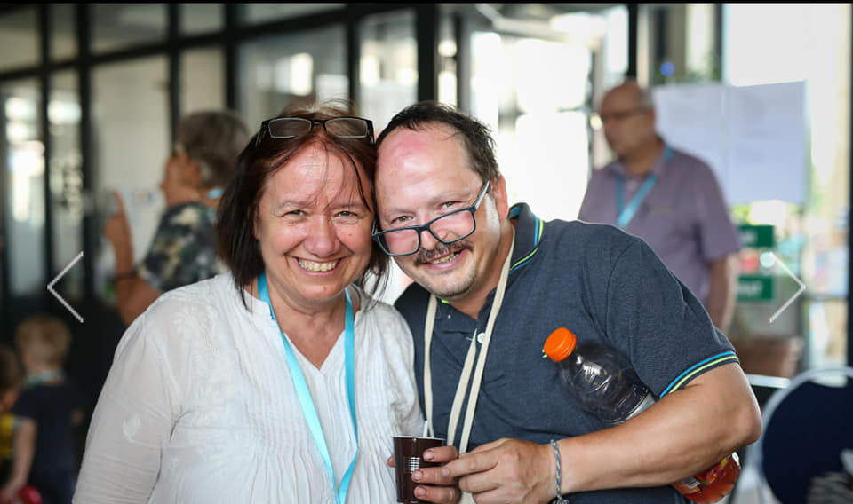

The placement is working with disabled and assists in a workshop.

Hosting volunteer will enable the placement to carry out work with added intercultural dimensions.

The volunteer can bring new ideas and different ways to provide social services. The voluntary service will be a challenge as a learning process for the volunteer of his or herself.

It will be an opportunity to take time out of the familiar environment and do something different, to provide practical or professional experience, but also to reflect and re-evaluate next steps (his/ her future orientation). The volunteer becomes an essential part of the daily life.

He/she will be welcomed by his/her mentor. When the volunteer starts at the workshop they will go through an induction period. They will be given information about the organisation, project, activities, and members. At all times the volunteers will be supported through a supervisor and will have regular meetings with their mentor to monitor and evaluate the project and deal with any problems arising. Volunteers are encouraged to use their own interests and experiences to set up personal initiatives and new activities for service users. Also, through the work itself, they will learn about how other communities live and work in other parts of the world and the inter-relationships between Europe and less developed countries, both economic and cultural.

He/she will work 30 hours a week. The volunteer’s main task is to frame the disabled people’s free time in a way that entertains and supports them in their abilities. This includes sport programs (riding, swimming, cycling, walking), creative programs and other activities, such as playing, singing, reading, painting … The volunteer can bring in his/her ideas in this program. There is a lot of room in the house and many sport, music and creative means. The volunteer also will help in the everyday life of the community. One day a week the volunteer can go to the workshop with the disabled people and help there. The program changes during the year, depending on different holidays and seasons. The volunteer also can take part in excursions, which we frequently make.

This is an example for the working hours, but it can change when we organise different events and programs.

8.00 -8.30 Preparation for the morning tasks

8.30 -9.00 Gymnastics, collection of all necessary things for the start: proper clothing passes etc.

16.30-18:00 The volunteer will be asked to do some creative work at the house, like preparation and cooking together

20:00- Every evening the mentor will help the volunteer to reflect on the day, personal issues etc. We organise once a month a meeting with all staff, where the volunteer will be also invited. The volunteer will help the creative activities in Gara workshop 2 times a week, every Wednesday and Friday. There the volunteer will help making candles, do simple rhythm activities, from 8:30-16:30. During these days the volunteer will get lunch in Gara. The volunteer will get a monthly ticket to use public transportation to get to Gara.

- Quality work and service.  
Volunteers will work from 9.00-15.00, from Monday till Friday.

We are looking for 2 volunteers.

## Magyar Kékkereszt Egyesület – Alcohol Rehab Centre - Dömös

The aim of the Magyar Kékkereszt Association (MKKE) is to help those seeking alcoholic and physical recovery from alcoholism and other addictive disorders. Our association carries out its activities in order to prevent and prevent the spread of addictions and to cure addicts. To this end, it also carries out youth information and prevention work (summer camps, youth groups) and aftercare rehabilitation activities. Our association maintains a healing institute in Dömös as the centre of healing work, to which those wishing to recover can apply from anywhere in the country by applying voluntarily and with a hospital referral.   
The headquarters are in Budapest, the background work and the administrative work take place here at the official headquarters, the support and treatment of the addicted patients take place in Dömös. In the framework of this application, we would like to accept volunteers for Dömös.

The target activity takes place in the home in Dömös as follows:   
1. Temporary home for addicts, social institution (40 people)   
2. Rehabilitation Institution for Addicts, is a health care institution.

Both are state-recognized and funded. The clients stay in the residential home for 3-4 weeks usually. If someone needs it, it is a maximum of one year. But a one-year stay is very rare and only possible in justified cases. In addition to the professional program, there are personal discussions, group discussions, lectures, and trips for clients. They receive full care, free for patients, as both the social and health care programs are funded by the state.   
A total of 25 people work for our organization, professionals with social, health, and psychological qualifications. The Reformed Church supports our work, so they provide 3 pastoral staff for the institution. Dömös is located on the right side of the Danube, 45 km from Budapest. Volunteers will work from Monday till Friday.   
Volunteers can serve not only as a role model, but someone who understands the struggle they’re facing.  Whether you provide a warm hello, a friendly face or a helping hand, just knowing you made a difference in someone's life makes it all worthwhile.   
We are looking for 2 volunteers.

## Immanuel Home for disabled children - Debrecen

www.immanuelotthon.hu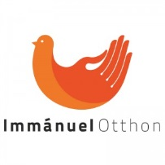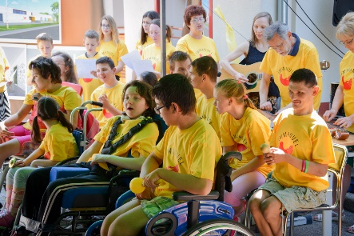

The Immanuel Home was founded in 1991 thanks to parents and specialists/professionals joining with the goal of providing room, space and "home" for those children whose parents were struggling with the problem of being rejected by every institution because of the condition of their kids. The main profile of the institution is to take care of 85 seriously disabled children and young people (between the age of 6 and 30) as a day-care centre; it is also open for those who fell out of the education system. The day-care centre is open from Monday till Friday. The daily routine of the volunteer will connect to the routine of the teams in the fields of youth teaching, therapies and leisure time activities.  
The volunteer is a full member of the team; their tasks will connect closely with the task of the pedagogy assistants.

**Tasks for the volunteer**In the mornings the youth arrive to the placement where they have breakfast. From 8.45 the teaching starts and they take part in the lessons/therapies within their group. If someone is unable to eat alone the volunteer is there to assist and also help in any other way if needed. During the afternoon sessions there are several extracurricular activities and therapies where the volunteers help the teams.

We are looking forward meeting you in one of our projects.



***ÖDE team***

Szabina Sztojka ([sztojka.szabina@jobbadni.hu](mailto:sztojka.szabina@jobbadni.hu))

Dániel Csáki ([csaki.daniel@jobbadni.hu](mailto:csaki.daniel@jobbadni.hu))  
W [odeprogramiroda.hu](http://www.odeprogramiroda.hu)  
Insta: odevolunteers